Design Report

PMU905

Part number with one PSU: 2509.8999.54

Part number with 2nd (reserved) PSU: 2509.8999.64

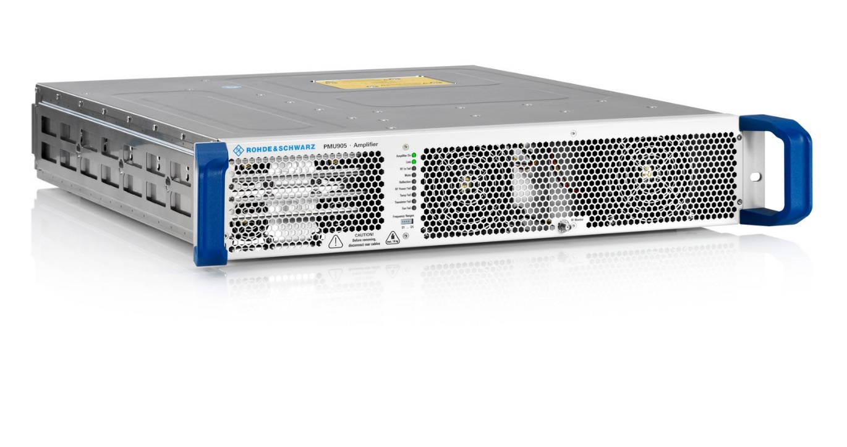

Content

1 Introduction / Basics 3

2 RF components and power supplies 4

3 Cooling of the amplifier 7

4 Self-protection of the amplifier 8

5 Efficiency of the amplifier 9

6 Control System and Interfaces 10

6.1 ICS interface 15

6.2 LPS interface 15

7 MTBF and Redundancy 16

7.1 Redundancy 19

8 Tasks and Milestones 19

9 Applied standards for the test reports 20

10 Maintenance and repair 21

10.1 Test Setup and Parameter Monitoring 21

10.2 Repair 23

10.3 Recommended Spare Parts 24

11 Annex 25

11.1 Technical Data 25

11.1.1 RF specifications 25

11.1.2 Mechanical specifications 25

11.1.3 Air cooling specifications 25

11.1.4 Electrical specifications 26

11.1.5 Environmental specifications 26

11.2 Plots 27

11.2.1 S21 (magnitude and phase) as function of Pin via 20 dB dynamic 27

11.2.2 Harmonics and spurious at Pout 200 W 28

11.2.3 Output noise 29

11.2.4 Phase and gain across RF pulse at Pout 200 W 30

11.2.5 Phase and gain between RF pulses at Pout 200 W 32

# Introduction / Basics

The amplifier PMU905 is based on the TV Transmitter Family TMU9 of Rohde & Schwarz. Rohde & Schwarz is the market leader in the field of terrestrial broadcasting transmitters worldwide.

The amplifier consists of an amplifier board with four BLF888 transistors and integrated harmonic filter, a power supply unit, alternatively an additional PSU as redundancy option and two fans which are changeable during operation. The following features characterize the R&S amplifier:

* Outstanding efficiency in the market through innovative amplifier design.
* Robust amplifier architecture
* Extremely compact design
* Simple integration in customer racks.

For the power transistors of the amplifier, mature 50-V LDMOS technology is being used. Through the close cooperation of Rohde & Schwarz with the semiconductor manufacturer and by the optimal matching of transistors, outstanding efficiency and a proven long-term stability is achieved.

Please note:

The Amplifier is designed to serve as a 450 WAV / 2500 Wpeak power unit in medium power DVB-T/T2 broadcast transmitters around the clock for an operating life expectancy of 10 to 15 years and more.

The present use case as a single frequency pulse amplifier with 200W Output power and < 10% duty cycle with reduced drain voltage (24V only) is indeed very far below the limits.

So please remind that when reading the following chapters.

For example:

The power loss per transistor is roughly 50 watts in that mode and the junction temperature will be lower than 50 °C on average (25°C air inlet, quiescent current is adjusted to 2 A for pulse shaping reasons). Therefore the 250W CW calculation below is already a worst case view.

The fans will probably rotate at pace one (which is 30%) most of the time with some chance to reach pace two (50%) on hot days.

In case of reflection at the amplifier's output the self protection will reduce the output power presumably at open or short circuit only because it's adjusted to act when the VSWR exceeds 1.5 - with 2.5 kW COFDM peak output power. Actually the reflection protection is not necessary because with 250 W and 24 V drain voltage the transistors will never fail due to output mismatch. Not from the voltage and not from the thermal point of view.

# RF components and power supplies

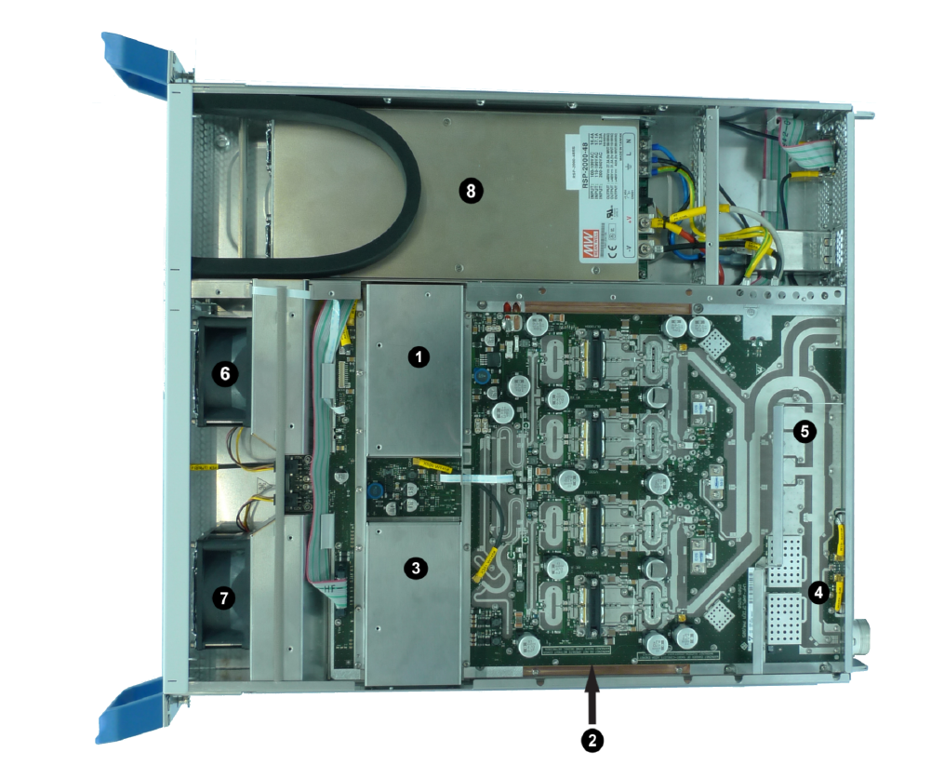

Amplifier PMU905 with one PSU (top cover removed)

The amplifier PMU905 consists of:

1. Preamplifier and driver amplifier,
2. Output stage with four BLF888,
3. Amplifier control board
4. RF detector,
5. Harmonic filter
6. Fan E1
7. Fan E2
8. Power supply unit

The amplifier operates as a linear amplifier in class AB. The four transistors of the output stage are organized in two balanced pairs which in turn form so to say a large balanced amplifier. The printed 3-dB-couplers in the balanced arrangements provide good isolation. This design ensures nearly perfect input and output impedances and it is very helpful in case of a transistor failure.

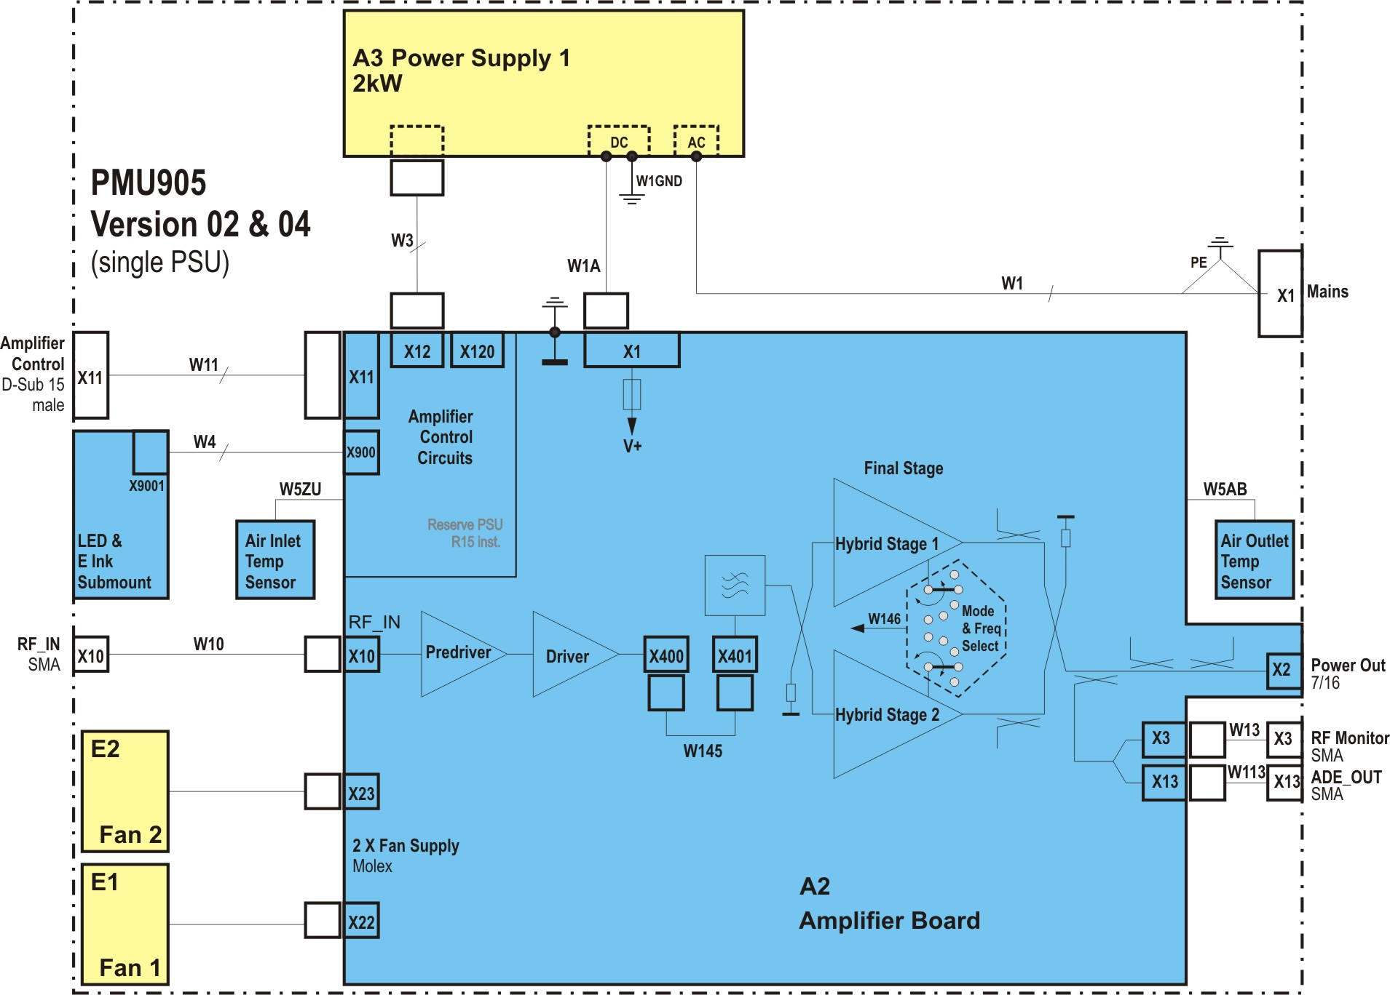

Block diagram with single PSU

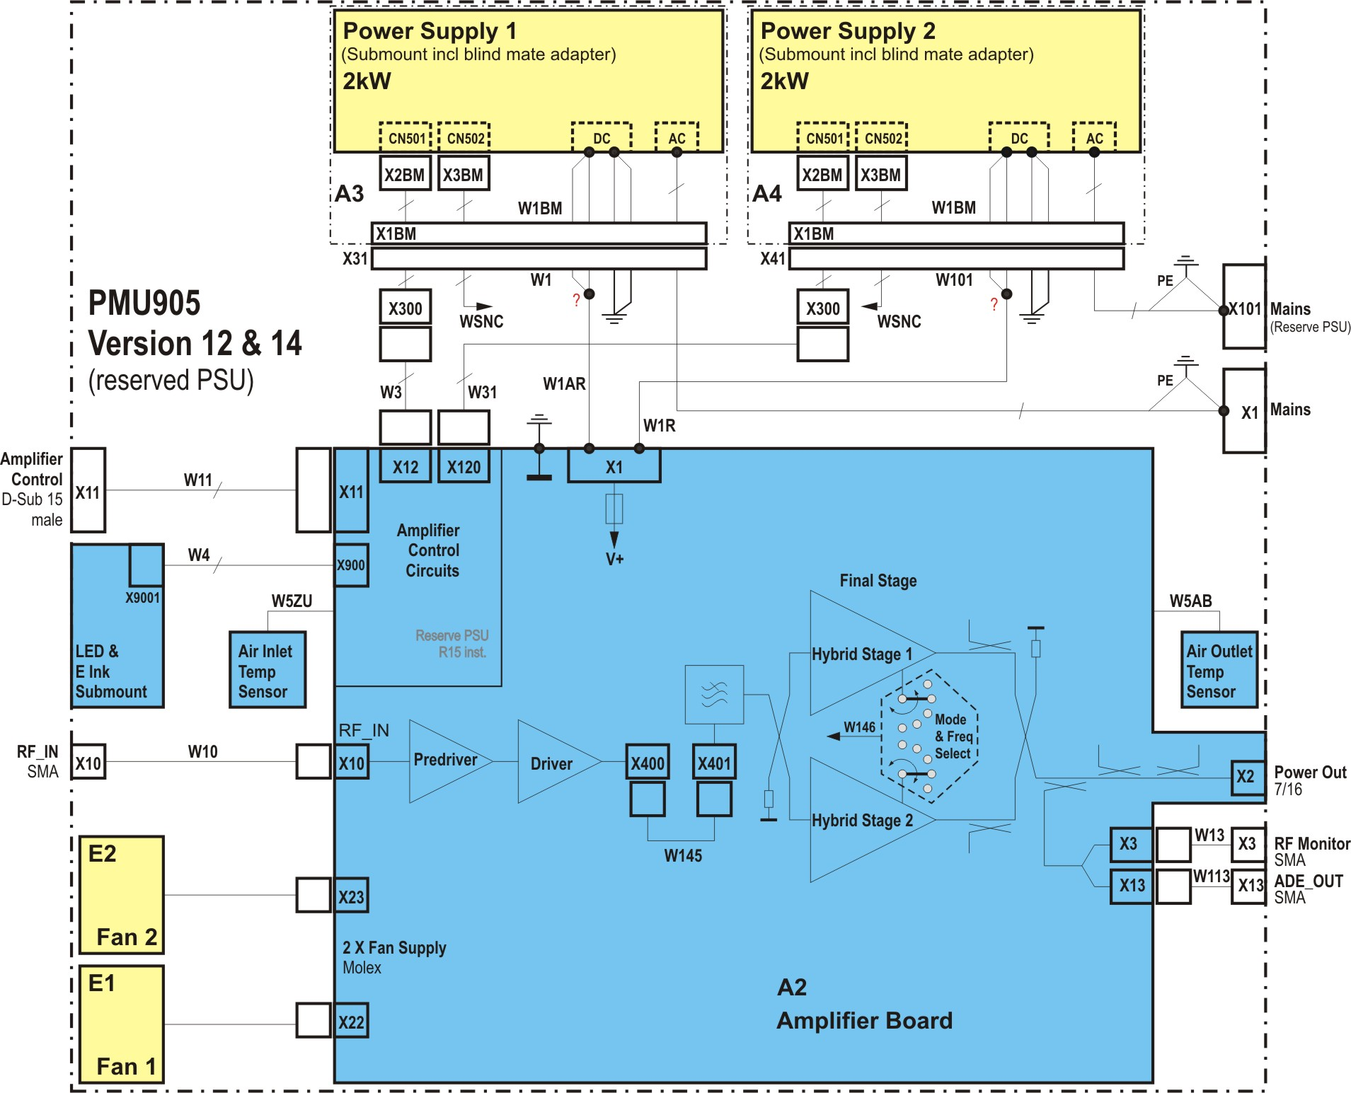

Block diagram with 2nd (reserved) PSU

The amplifier has a 2 kW power supply unit (PSU) which generates the amplifier operating voltage and the 12 V auxiliary voltage. Alternatively, an identical power supply unit (2nd PSU) can be connected in parallel as an active redundancy.

With the 2nd PSU as a redundant component, the PMU905 is still on air in case of power supply failure. The defective power supply is hot swappable, i.e. it can be swapped during operation. The power supply is easily changeable via the font panel. The amplifier can remain in the rack.

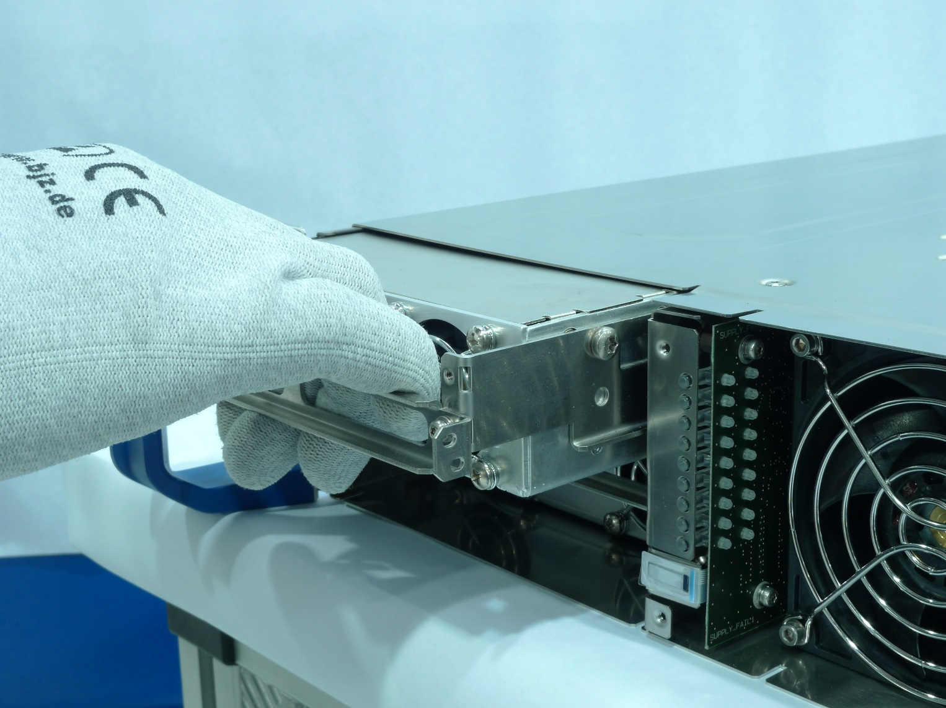

Hot plug power supply

# Cooling of the amplifier

A copper high-power heat sink and two fans provide the necessary cooling. The cooling system features the following:

* The amplifier circuitry is cooled by means of thermal conduction to the heat sink which dissipates heat to the flow of cooling air inside the amplifier.
* Two fans, see 1 and 2, which realize the air flow from the front to the rear side are mounted behind the front panel. They can be replaced while the amplifier is still in operation also if the amplifier is installed in the rack.
* The speed of the fans dependents on the heat sink temperature (four steps).
* The power supply unit has its own fans which dissipate heat generated by the power supply unit.

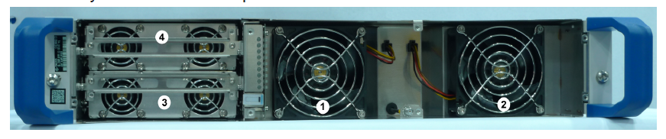

Fans and power supply units (front cover removed)

# Self-protection of the amplifier

In order to achieve outstanding reliability, a very high value was placed on the self-protection in the development of the RF module.

**The protection mechanisms are field proven in the demanding 24/7 operation of broadcasting. The RF module can even cope with the event of high reflection as a result of broken antennas or defective high power rf cable. We sold several thousands of amplifiers with these protection around the world. A solution based on a circulator is not necessary to protect the RF module.**

The amplifier has a series of self‑protection and monitoring circuits which protect the amplifier against irreparable damage in the case of impermissible operating conditions and enable transmission to continue as long as possible. The following mechanisms are available.

* Power supply unit monitoring
* Output power limitation
* Temperature monitoring incl. fan control
* Reflection monitoring

Power supply unit monitoring

The power supply unit is protected by:

* Over temperature shutdown for the duration of over temperature
* Short‑circuit current limitation (fold back)
* Overvoltage limitation (on DC side).

Without the 2nd power supply unit a failure of the power supply unit will lead to a failure of the whole amplifier.

If a standby power supply unit is installed, there will be no operational restrictions. However, the amplifier will be completely deactivated if both power supply units fail.

Output power limitation

To prevent an overdrive the output power is limited so that no damage to the amplifier at high values of reflected power is possible.

Temperature monitoring and fan control

The power supply units and the amplifier circuit each have a dedicated hardware over temperature shut down mechanism.

If a temperature threshold is exceeded, the amplifier is disabled, whereby the threshold for over temperature shutdown is above the permissible operating temperature. It is ensured that the remaining overall power loss does not lead to overheating of the amplifier, even in case of total failure of the cooling system.

The fan has four different speed settings, whereby the second speed is the standard speed which has been optimized with regard to the average junction temperature of the output stage and the acoustic noise generation.

To ensure continuous operation as long as possible, the temperature and fan control functions work together as follows:

* If the temperature rises in the amplifier circuit, the fan speed is increased before the hardware shutdown threshold is reached.
* If this is not enough, at temperature above 83 °C the amplifier begins to reduce the output power stepwise.
* At temperatures above 90 °C, the amplifier remains switched off by means of hardware as long as the over temperature exists.
* An appropriate hysteresis is integrated to prevent permanent on/off.

In addition, the inlet and outlet air temperature is measured by means of two sensors, on the front and rear side of the amplifier board, thermally insulated from the rest of the printed board. This allows, f. e. the detection of a fouled air filter.

Reflection monitoring

A distinction is made between the following types of reflection monitoring:

* With major reflection above reflection threshold 2 (s = 2 at full output power), the power is briefly cut off completely at first; a soft start is performed immediately afterwards. If any reflection remains, the amplifier protects itself by reducing the output power. The time constant selected for the shutdown is such that damage to the amplifier is prevented in the case of total reflec­tion and at all phase angles of the reflection at the RF output.
* With weaker or slowly increasing reflection above reflection threshold 1 (s = 1.5 at full output power), the output power is reduced without preceding shutdown. When reflection disappears, the power reduction is canceled automatically.

Emergency Power Off (external)

The amplifier can be disabled externally by means of the SHUT_DOWN signal, for example to ensure self‑protection for subsequent devices. The signal, which is fail save in case of cable breaks, is fed via an optocoupler related to CAN_GND and is insulated from the ampli­fier’s ground. The output power is suppressed as long as no connection to CAN_GND exists.

# Efficiency of the amplifier

Efficiency depends on the linearity of the output signal. The linearity of the PMU905 can be improved by a higher DC voltage (which can be adjusted via the control menu) which results in less efficiency.

The table below shows the calculation for 250 W CW.

|  |  |
| --- | --- |
| Pavg / W transistor in W | 70 |
| n transistor in % | 41.0 |
| P_DC transistor | 170 |
| Pv transistor | 100 |
| Number of transistors | 4 |
| **P_DC_PA** | **680** |
| Pv_PA | 400 |
| **Poutavg in W** | **250** |
| **Pv driver, preamp, control, etc** | **40** |
| **DC-power in W** | **720** |
| DC voltage in V | 24.0 |
| DC current in A | 30 |
|  |  |
| n power supply (Meanwell) in % | 93 |
| cos phi (Meanwell) | 0,97 |
|  |  |
| AC in W | **774** |
| AC in VA | **798** |
|  |  |
| Power dissipation in W | **524** |
| Efficiency in % | **32,5** |
| **RF-output power AVG in W** | **250** |

# Control System and Interfaces

The amplifier is controlled means by a microcontroller with the necessary firmware and the following circuits:

* Clock generator
* CAN-Bus controller
* ADC and PWM with buffer and driver
* Interface for lifelines and CAN-Bus sorting lines
* DC/DC-converter
* Voltage monitoring

The control system controls, f. e. the fan speed, monitors the input and output power, the temperature and last but not least recognizes defective transistors.

The following LEDs for indicating states and faults are on the front panel:

|  |  |  |  |
| --- | --- | --- | --- |
| Name |  | Signal | Reaction |
| AMPLIFIER ON | H1 | ⚫ LED, green | The LED lights up when the amplifier is ready for operation, i. e. the supply voltage is present and the amplifier is in operation |
| LINK | H2 | ⚫ LED, green | Amplifier communication with the CAN Bus.   * Flashes rapidly: No master * Flashes slowly: Not operational but communication link present * Always on: Normal communication * Off: Processor is not supplied with power (no V_AUX) |
| RF IN FAIL | H3 | ⚫ LED, yellow | Version 04 and 14: The LED lights up if the RF input level is below preset threshold  **Version 54 and 64: no function** |
| MUTE | H4 | ⚫ LED, yellow | The RF output signal is suppressed  (caused by the SHUT_DOWN command, with the RF_IN_FAIL message or with the RF_MUTE signal). |
| REFLECTION | H5 | ⚫ LED, yellow | The LED lights up if the reflection at the RF output exceeds a threshold. The message is stored in a nonvolatile memory in the amplifier and can be reset at the remote operation. |
| RF POWER FAIL | H6 | ⚫ LED, red | The LED lights up if the RF output power is below the preset threshold |
| TEMP FAIL | H7 | ⚫ LED, red | The LED lights up if, due to over temperature, the amplifier power is reduced or the amplifier is completely shut down. The message is stored in a nonvolatile memory in the CAN controller and can be reset at the remote operation.  The power is reduced or suppressed for as long as over temperature is present. |
| TRANSISTOR FAIL | H8 | ⚫ LED, red | The LED lights up if a transistor fails in the output stage or driver. |
| FAN FAIL | H9 | ⚫ LED, yellow | The LED lights up if one or more fans fail. |

Indication of other operating states:

* H6 – H8 flash

A problem has occurred during initialization. Certain hardware conditions are not fulfilled, e. g.: Internal operating voltages are missing.

* H3 –H5 chaser light

Bias adjustment is active (duration: approx.. 5 min.)

* H1 – H8 flash for 10 s

The command to detect an amplifier has been activated

Status LEDs

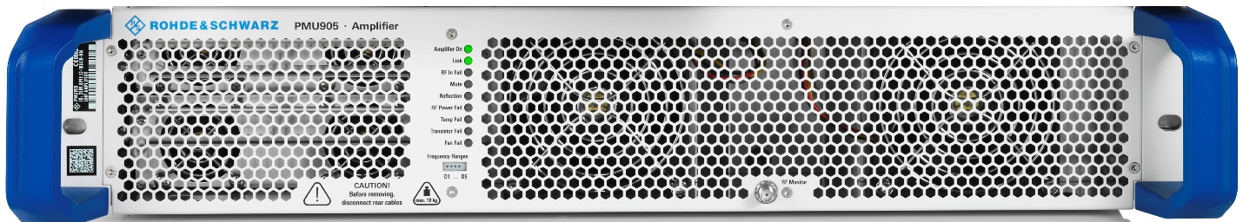

RF Monitor

Front RF test connector

At the RF Monitor test point, a portion of the output signal is provided via a directional coupler. This allows evaluation of the signal quality. The coupling attenuation is available via CAN.

Interface for amplifier control

The connector is placed on the rear panel of the amplifier.

X11, Sub-D male 15 pin, Amplifier Control

|  |  |  |  |  |  |  |
| --- | --- | --- | --- | --- | --- | --- |
| **Name** |  |  | **Range** |  | **Pin** | **Description** |
| *SORT1* | B | D | 0…13V | P | X11.1 | Sort-PIN 1, short circuit protected, based on *CAN_GND,*  <1V: low, >8V: high |
| *ADGND* | I | A | 0V ± 1V | P | X11.9 | Analog und digital ground (inside amp isolated to *GND* to prevent ground loops) |
| *GND* | I | A | 0V | P | X11.2 | Amplifier ground |
| *FAULT* | O | D | Open Collector, I ≤ 10mA (with ESD protection), Ri ≤ 100Ω, U≤12V low: ≤ 2.5V bei 10mA | P | X11.10 | Amplifier fault  o*pen:* amplifier O.K. *low (*≤ 2.5V)*:* **based on CAN_GND**, amplifier fault: temperature or reflection to high, |
| *RESET* | I | D | 0…5V, ≤ 5 mARi ca. 3.3kΩ (Optocoupler input) | P | X11.3 | *high* (≥ 1mA, ≥ 3.0V)*:* Reset, *reset of storaged messages* *TEMP_FAIL, REFLECTION*; based on *ADGND* |
| *AMPL_ON* | I | D | 0…5V, ≤ 5 mA, Ri ca. 3.3kΩ (Optocoupler input) | P | X11.11 | *high (≥ 1mA, ≥ 3.0V)*: amp ON;  based on A*DGND* |
| *VREF_PWR* | I | A | 0...5.58V, based on auf ADGND RL = 74.4kΩ, 4V = nominal | P | X11.4 | Voltage reference for output power,  based on *ADGND* |
| *SHUT_DOWN* | I | D | 0…13V, ≤ 5 mA Internal Pull-up on *CAN_V+* via Optocoupler | P | X11.5 | Amplifier emergency switch off, *open:* amp not active (Mute) low (*≥ 2mA, ≤ 3.0V)*: amp in normal operation, **based on *CAN_GND*** |
| *CAN_GND* | I | A | 0V ± 1V | P | X11.13 | CAN-Mass (isolated to *GND*) |
| *CAN_L* | B | D | CAN_L | P | X11.6 | CAN Low |
| *CAN_H* | B | D | CAN_H | P | X11.14 | CAN High |
| *CAN_V+* | I | A | + 12V ± 1V, *≤* 40 mA (bei 100% dominant level) tyical: 15mA | P | X11.7 | Voltage for CAN-Transceiver**; based on *CAN_GND*** (isolated to *GND*) |
| */AC_OK* | O | D | Open Collector, I ≤ 10mA (with ESD protection via Z-Diode), Ri ≤ 100Ω, U≤12V low: ≤ 1.5V at 10mA | P | X11.15 | AC phase monitor,  *low:* AC O.K. *open:* no AC, phase not ok, voltage too high or too low; based on GND |
| *SORT2* | B | D | *0…13V* | P | X11.8 | Sort PIN 2, short circuit protected, based on *CAN_GND, <1V: low, >8V: high* |

It is possible to communicate with max. 24 amplifier simultaneously on one CAN-Bus. With the help of so called “Sorting lines” it is possible to set the sequences of the amplifier automatically.

Sorting of amplifier in one rack

All components which are several times in a system, f. e. amplifiers, support the sorting. Each component reports via status the state of the sorting line. (see. 5.8 Status Message – Status PDO of the document Software Interface Description). The sorting lines can be active driven by a Service Data Object (SDO). The first component on the bus or before the sortable component is always a VSS, a CAN-Bus-Adapter or a Drive9-Ctrl and these components drive the sorting lines always.

The construction of the system brings the following limitations for the sorting:

* 1. Only complete systems are sortable completely (leaks f. e. if amplifier are out, prevent the complete sorting).
  2. Only components of the same type are sorted.



Procedure of the sorting:

1. Inform all components that they should not drive the sorting lines
2. Evaluate the state for the sorting lines of all components. The component which has an active sorting line is next to the Master.
3. Notice the position and store the position of the component with SDO.
4. Inform this component that it has to drive its sorting line active.
5. Evaluate the state for the sorting lines of all components. The component which has an additional active sorting line is the next in the chain of the components.
6. Notice the position and store the position of the component with SDO.
7. Continue with 4. until no new components are found.
8. Inform all components that they do not drive the sorting lines anymore.

The procedure is finished if all known and sortable components are sorted.

SDOs

|  |  |  |  |
| --- | --- | --- | --- |
| Index | Subindex | read/write | meaning |
| 0x2400 | 0x01 | r/w | State of both sorting lines (whether the lines are active driven or not). 8Bit  0 = not driven  1 = driven  2 - 255 = not defined |
| 0x2400 | 0x02 | - | reserved |
| 0x2400 | 0x03 | r/w | Memory for the position of the component  0xFF remains unused (not valid / not defined)  This value is stored persistently |

Status Message - PDO (Except of chap. 5.8 of the document Software Interface Description)

Each component has on byte 0 of the status message a fixed value. The bits are defined as following:

|  |  |  |  |  |  |  |  |
| --- | --- | --- | --- | --- | --- | --- | --- |
| Byte 0 | | | | | | | |
| Bit 7 | Bit 6 | Bit 5 | Bit 4 | **Bit 3** | **Bit 2** | Bit 1 | Bit 0 |
| 0 | SW/HW Mismatch. | SwUpdateRunning | Reserved | **State of the sorting line 2** | **State of the sorting line 1** | Reserved | Reserved |

## ICS interface

The CAN-Bus interface on connector X11 (see section 6 Interface for amplifier control) can be used for the Integrated Control System of ESS.

**Please see the document “Software Interface Description”.**

## LPS interface

The signals *FAULT* and *SHUT_DOWN* on connector X11 (see section 6 Interface for amplifier control) can be used for the Local Protection System of ESS.

An interlock can be built with the input signal SHUT_DOWN. The amplifier is muted if the signal is “open”.

**The reaction time is less than 30µs.**

The amplifer is ready for operation if the signal is “low” – closed to CAN_GND.

The output signal FAULT is active if the amplifier has an error, the signal is “low” based on CAN_GND. This will happen if the temperature is too high or if the reflection is too high. (see also section 4, There is the behavior of the amplifier descripted.) The FAULT is inactive if the signal is “open”. As it is an open collector the signal level based on the level of CAN-V+.

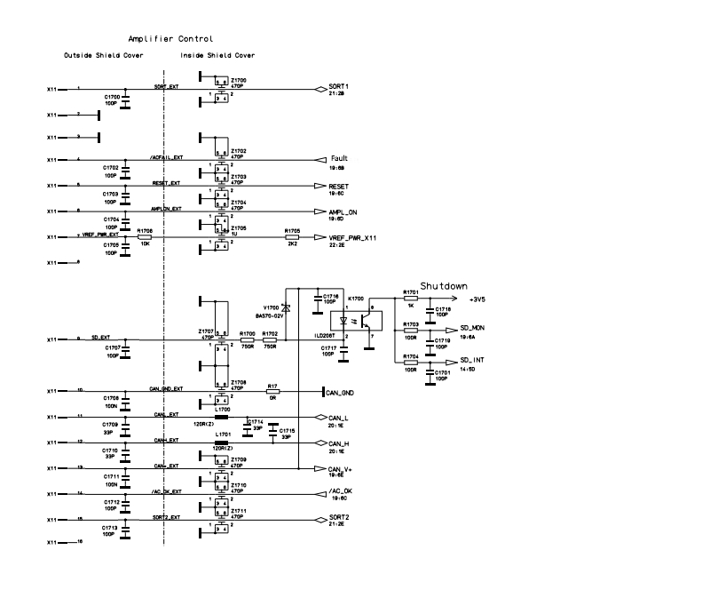

*Interface diagram of the Amplifier Control*

# MTBF and Redundancy

Junction temperature of the output transistors

The junction temperature is calculated for the nominal output power of 250 W CW at room temperature (25°C). The allowable junction temperature of the BLF888 is 225°C (see data sheet). Especially the CW operation and low DC supply (24 VDC) result in temperature values ~~that are~~ well below the specified maximum value. The thermal resistance R th j-c is also available from the data sheet. The thermal resistances Rth c-hs and Rth hs-liqu were determined by simulation and confirmed by measurements. Depending on the DC Voltage the junction temperature is within the range of 60°C for an air inlet temperature of 25°C.

Example for 250W CW operation of the amplifier system:

Tj/°C = Tair + Pv x (Rth,j-case + Rthcase-heatsink + Rth heatsink-air)

250 W / 4 transistors = 62.5 W

Rth j air = 0,38 K/W

Pv / W = Pout x (1/ƞ – 1) = 62.5W x (1/0.41 – 1) ~90W

Tj/°C = 25°C + 90 W x 0.38 K/W = 60°C

Transistor

The Time to Failure for the BLF888 is more than 10^4 years for a junction temperature of 100°C and a current of 5.3 A.

The assumption of 100°C is well above the mentioned range and presents a worst case scenario.

The MTBF is so good because the amplifier is designed for 450 W average output power DVB-T (2,5kW Peak) and the calculation above is done for an operation at 250 Wcw.



TTF as function of the junction temperature and drain–source current (excerpt from the data sheet of BLF888)

Operational Life

All major amplifier components (Preamplifier and driver amplifier, output stage, amplifier control, RF detector, Harmonic filter, fans, power supply unit) are originally designed as a reliable investment for 24/7 operation. **The transistors are operated far away from the maximum permissible supply voltage and have sufficient power reserves.**

Power Supply Unit:

At an average ambient (= air inlet) temperature of 25 °C and full power (2000W PoutDC, 160W PV) the supplier’s MTBF calculation shows appr. 160000 hours.

At 650 W PoutDC (appr 65 W PV) the estimated MTBF of the PSU is 350000h.

PMU905 incl. Power Supply Unit

At full Power (450WAV / 2,5kWPeak / 44VDC / broadband mode) the calculated MTBF for the amplifier is

* 9,4 years (12170 fit)

**At 250Wcw** (24VDC / broadband mode) the estimated MTBF for the amplifier is

* **15,3 years (7460 fit)**

**Note:**This is valid only within the Lifetime of the fans (12 Years, 10% fraction failure -> MTBF approx. 850000h) and the Lifetime of the used electrolytic capacitors which is approx. 25 Years.

The calculation above doesn’t take into account the 100% fan redundancy at this conditions, there reduced speed and the optional 100% PSU redundancy which both leads to a significant improvement of the amplifier’s availability.

**Assumed a constant Failure rate:**

**The requirement for the MTBF is 70000 hours. The MTBF of the amplifier is 135000 hours.**

**The probability that the amplifier is out of order within 70000 hours: P(70000h) < 15%.**

**The yearly operation is 6000 hours.**

**The probability that the amplifier is out of order within 6000 hours: P(6000h) < 0.00000002%.**

**It is possible to improve this very good values with the 2nd power supply. See also the alternative position in the quotation and the chapter Redundancy**

## Redundancy

The PMU905 consists of four BLF888 and is designed for 450 W avg, 2.5 kW peak. If one or two of the transistors are broken the amplifier can deliver 200 W cw with the remaining BLF888.

The amplifier with the 2nd power supply as a redundant component will furthermore increase the reliability.

At 250Wcw / 24VDC the two fans are 100% active redundant.

# Tasks and Milestones

The R&S process “Implementation of Customers Projects (IoCP) and the framework contract are the base of the activities/tasks.

|  |  |  |
| --- | --- | --- |
| Tasks and Milestones | Date | Remark |
| Kickoff meeting | 2018-02-09 | Internal |
| Project setup complete (MS2) | 2018-02-16 | Internal |
| Kickoff meeting | 2018-02-28 | ESS |
| Design report | 2018-02-23 | ESS |
| Design review meeting | 2018-02-28 | ESS |
| Product desciption | 2018-03-29 | Internal |
| Design freeze (MS3) | 2018-03-29 | Internal |
| Final test procedure | 2018-04-27 | Internal |
| Software adapted | 2018-04-27 | Internal |
| Software released | 2018-05-15 | Internal |
| FAT (MS4, Release of prototype) | 2018-05-30 | Internal |
| Delivery of two prototypes | 2018-06-05 | ESS |
| Final acceptance (MS5) | 2018-08-08 | ESS |
| Service Handover (MS6) | tbd | Internal |
| 36 amplifiers | Seperate order | ESS |
| 44 amplifiers (depend on IOT) | Seperate order | ESS |

# Applied standards for the test reports

The PMU905 belongs to the equipment class: 2.10 (Broadcast transmitter)

Harmonized standards: ETSI EN 302 296-2 V1.2.1

Conformity with: EN 60950-1: 2006 + A1:2010 + A12:2011

ETSI EN 301489-1 V1.9.2

ETSI EN 301489-14 V1.2.1

EN50581:2012 (ROHS)

Rec.1999/519/EG; 26. BlmSchV

Rec TP SSB RU005

Immunity tests

Electrostatic discharge according to EN 61000-4-2

Radiated radio-frequency, electromagnetic field, according to EN 61000-4-3

Electrical fast transient/burst according to EN 61000-4-4

Surge according to EN 61000-4-5

Conducted disturbances, induced by radio-frequency fields according to EN 61000-4-6

Voltage dips and short interruptions according to EN 61000-4-11

Voltage dips and short interruptions according to KN 61000-4-11

Climatics

High Temperature Test: EN60068-2-2 Operational/+45°C/16h

Low Temperature Test: EN60068-2-1 Operational/1°C/16h

Damp Heat Test: Device class A1, (+45 °C/95% r.H./constant)

Transient Condensation Test

Mechanical environmental test

Sinusoidal vibration test: EN60068-2-6:2008

Random vibration test: EN60068-2-64:2008

Shock test: MIL-STD-810E

# Maintenance and repair

The PMU905 is designed to be used without maintenance.

But you can increase the availability and performance of the amplifier if you monitor the rf parameters of the device time by time. It is possible to recognize changes early and initiate timely measures to prevent a break down of the amplifier.

## Test Setup and Parameter Monitoring

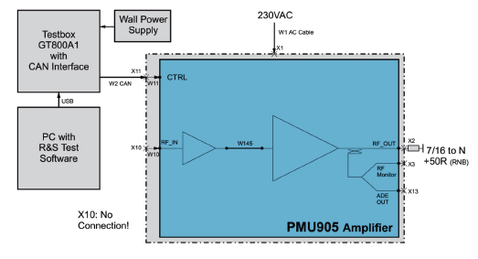

Many amplifier parameters can be monitored with the **TX9 Service-Panel**, running on the PC.

The following windows are self explanatory and show the possibility.

**Main window** (f.e. 400 W avg Doherty mode)

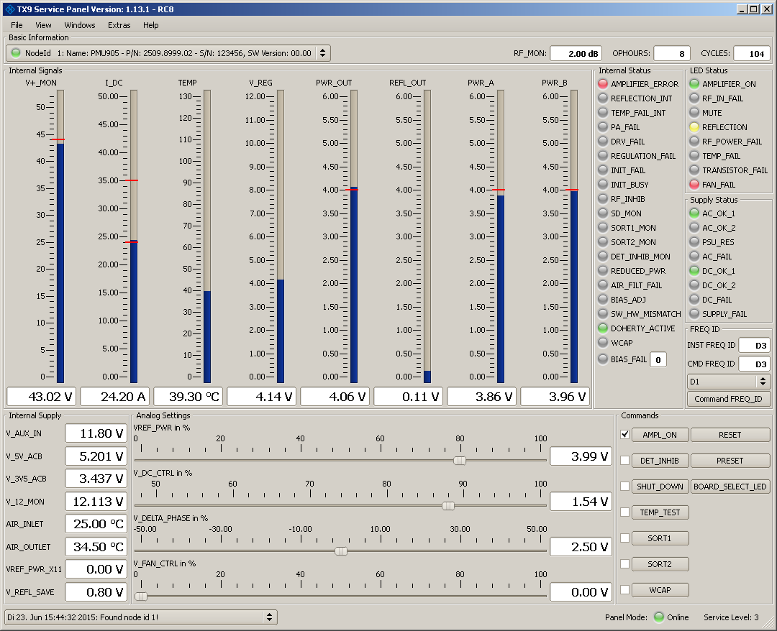

|  |  |  |
| --- | --- | --- |
| **Window “Device Data”** |  |  |
|  |  |  |
| **Window “Current Panel”** (f.e. 400 W avg Doherty mode) |  |  |

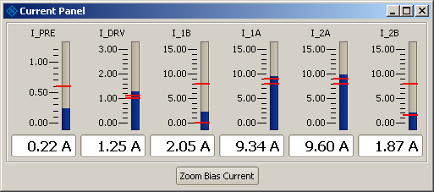

There are further possibilities which are useful for service and repair.

## Repair

If you like to do the repair by yourself, R&S recommends a special service training.

During the training you will get a Service Manual Level 2.

The following is an excerpt of the manual.

Tools and Materials

* ESD workstation and equipment
* Torx screwdriver T6, T8, T10, T20, T25
* Torx torque screwdriver T6, T8
* Torx offset screwdriver T8
* Cross-tip screwdriver, size 2
* Contact thermometer
* Digital multimeter

R&S TX9-PA Service Kit

* Basic kit (R&S part number 2600.7703.20)
* Expansion kit for transistor replacement (R&S part number 2600.7703.40)
* Mains cable (R&S part number 3586.6406.00)

Additional documentation

* Service Manual Level 2, only available after service training (R&S no. 2509.8901.02)
* R&S Assembly drawings (R&S no. 2509.8999.01 D1 to D7)
* R&S Circuit drawing (R&S no. 2509.8999.01 S1, S2)
* R&S Circuit component lists (R&S no. 2509.8999.01 SA, 2509.9037.01 SA)
* R&S Spare part list (R&S no. 2509.9037.01 SA)
* R&S Spare part assembly drawing (R&S no. 2509.9037.01 D1)

Replaceable Modules and Components

If defects occur, the following modules and components are removable and changeable

* Fans
* Power supply unit
* Driver transistor
* Output stage transistors
* Software and firmware
* LED board

A functional test must be carried out on the amplifier after a module and/or component has been replaced (except if a fan or power supply unit has been changed)

The procedures for the replacing and the test are described in the complete Service Manual Level2.

## Recommended Spare Parts

See Quotation/Options/Recommended Spare Parts.

The numbers of the recommended spare parts are calculated for:

* 24/7 operation
* five years
* cw-mode
* installed base of 36 amplifier

# Annex

## Technical Data

### RF specifications

|  |  |  |
| --- | --- | --- |
| Main parameters | | |
| Frequency range |  | 704 MHz +/- 10 MHz |
| Nominal output load |  | 50 Ω |
| Nominal power |  | 200 W (53.0 dBm) |
| Max. power |  | 400 W (56.0 dBm) |
| Dynamic range |  | min. 20 dB |
| Nominal power gain |  | 65 dB |
| Harmonics | at 200 W | < –70 dBc |
| Spurious | carrier offset > 10 Hz | –80 dBc (nom.) |
| Noise figure |  | < 10 dB |

|  |  |  |
| --- | --- | --- |
| Input | | |
| Nominal input impedance |  | 50 Ω |
| Input level for nominal output power | at 200 W | -3 dBm |
| Input VSWR | at 50 Ω | max 1,2 |
| Maximum input level | RF | 13 dBm |

|  |  |  |
| --- | --- | --- |
| Output | | |
| Nominal output impedance |  | 50 Ω |
| Forward output power | at VSWR < 1.5:1 | without foldback |
| Power reduction VSWR | amplifier self protection | > 3 : 1 |
| Output mismatch protection, VSWR |  | > 3 : 1 |

|  |  |  |
| --- | --- | --- |
| RF sample signals | | |
| RF sample signal coupling factor | RF forward and reflected sample ports | see test report for details |

### Mechanical specifications

|  |  |  |
| --- | --- | --- |
| System size | | |
| Dimensions amplifier | H x W x D | 88 mm x 511 mm x 581 mm (prepared for rack mounting) |
| Weight | With one power supply | approx. 15 kg |

|  |  |  |
| --- | --- | --- |
| RF and sample connectors | | |
| RF input port |  | SMA |
| RF output port |  | 7/16 |
| RF sample port | forward output power, front panel and rear panel | SMA |

### Air cooling specifications

|  |  |  |
| --- | --- | --- |
| Air flow | | |
| Air flow at ambient temperature | <30°C | 50 m3/h |
| Air flow at ambient temperature | ≥30°C | 100 m3/h |

### Electrical specifications

|  |  |  |
| --- | --- | --- |
| AC supply voltage | | |
| Nominal operating voltage range |  | 90 V to 264 V AC, single phase, 50 Hz to 60 Hz ± 6 % |
| Power consumption | For CW operation at 400 W, 50 Ohms | < 1.3 kVA |

### Environmental specifications

|  |  |  |
| --- | --- | --- |
| Temperature loading | operating temperature range | +1 °C to +45 °C |
| Damp heat |  | 95 % rel. humidity at 40°C,  without condensation |
| Altitude | operating altitude | up to 2000 m |

## Plots

### S21 (magnitude and phase) as function of Pin via 20 dB dynamic

Measurement device

Vector analyzer R&S ZNB8

Meaning of the markers and scaling

Pin: -32 dBm to -12 dBm, 2 dBm pro division

Gain: 64 dB to 69 dB, 0.5 dB pro division

Phase: -12° to -2°, 1 grd pro division

The output power of 200 W is reached at the marker M2.

The input power at the marker M1 is 10 dB below the input power at marker M2.

S21 (magnitude)

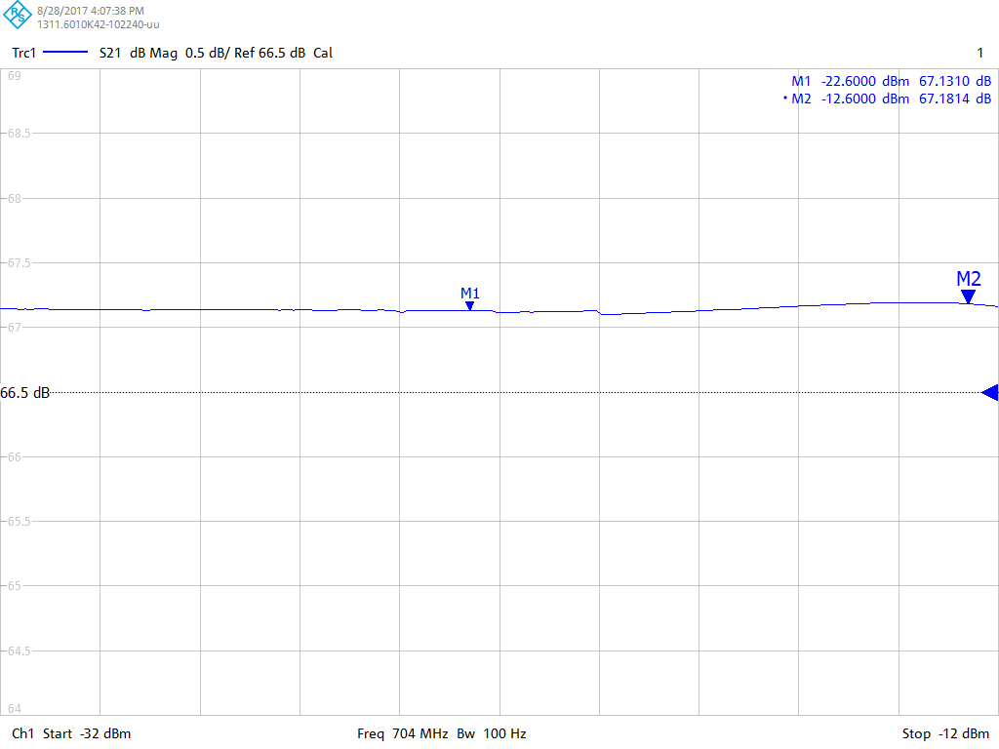

2,5 W 250 W

Result

Gain flatness over 10 dB dynamic range: 0.05 dB

S21 (phase)

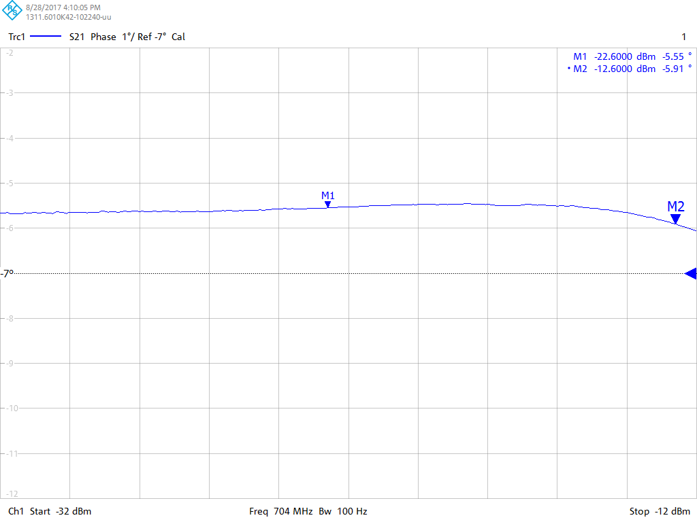

2,5 W 250 W

Result

Phase flatness over 10 dB dynamic range: 0.36°.

### Harmonics and spurious at Pout 200 W

Measurement device

Spectrum analyzer R&S FSW50

Signal generator R&S SMA100A

Meaning of the markers and scaling

The cw-signal of 200 MHz at 704.420 MHz and the 2nd harmonic at 1408.840 MHz are shown at the same plot.

The 3rd harmonic is too small to be displayed, because the spectrumanalyser needs an attenuation of 28 dB because of the high power, 200 W, of the cw signal.

0 dBm refers to 200 W at 704.420 MHz

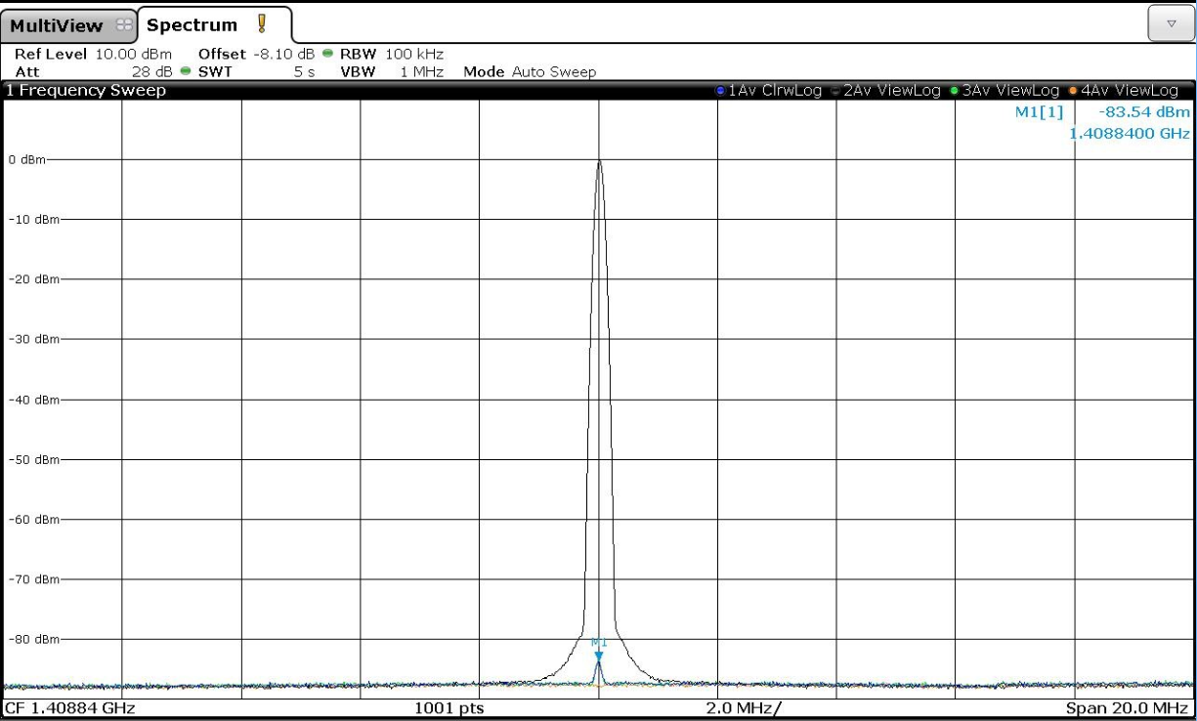

Result

2nd harmonic is lower than -89 dBc (83 dB + 6 dB due to the directional coupler), 3rd harmonic is lower than -95 dBc (87dB + 12dB due to the directional coupler) and spurious are lower than -87 dBc at output power of 200 W.

### Output noise

Measurement device

Spectrum analyzer R&S FSW50

Signal generator R&S SMA100A

The plot displays the noise spectrum at the output of the PMU905 at the band width of 100 kHz. The signal input of the PMU905 is terminated with 50 Ohm. The PMU905 is on, the gain is 67 dB.

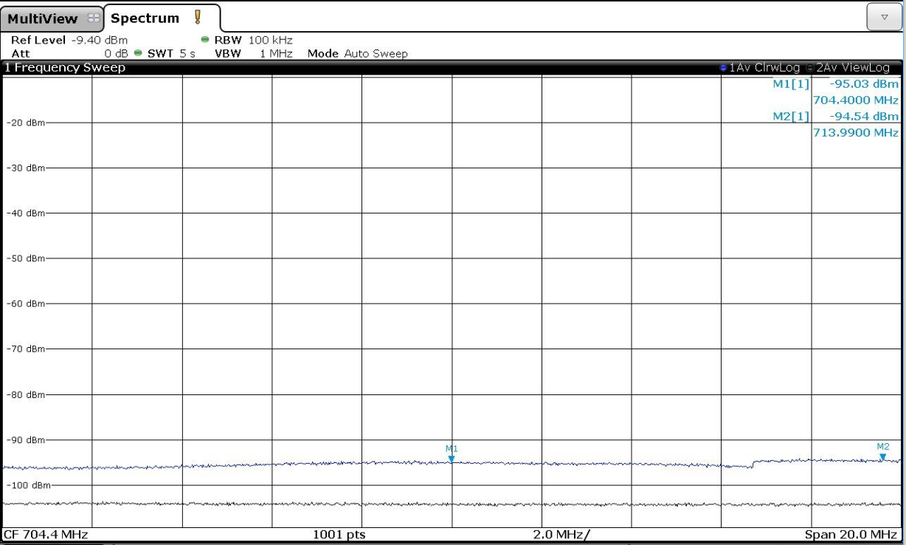

**Result**

Noise spectrum: -95 dBm at the band width of 100 kHz-> **-145 dBm/Hz**

Gain of the PMU905: **67 dB**

Coupling factor of the directional coupler: **45 dB**

-145 dBm/Hz - 67 dB + 45 dB = **-167 dBm/Hz**

**NF: -167 dBm/Hz – (-174 dBm/Hz)** (at room temperature of 290 K)

**NF: 7 dB**

### Phase and gain across RF pulse at Pout 200 W

Measurement device

Spectrum analyzer R&S FSW50

Signal generator R&S SMA100A in pulse operation

Pulse characteristic: Duration 4 ms, repetition rate 70 ms,

The FSW50 has got the 10 MHz reference of the SMA

Meaning of the marker and scaling

The markers did not work correct under the pulse operation.

Pulse magnitude: 0.2 dB / division

Phase: 1° / division

**Signal generator only, Pout -10 dBm at 704.420 MHz**

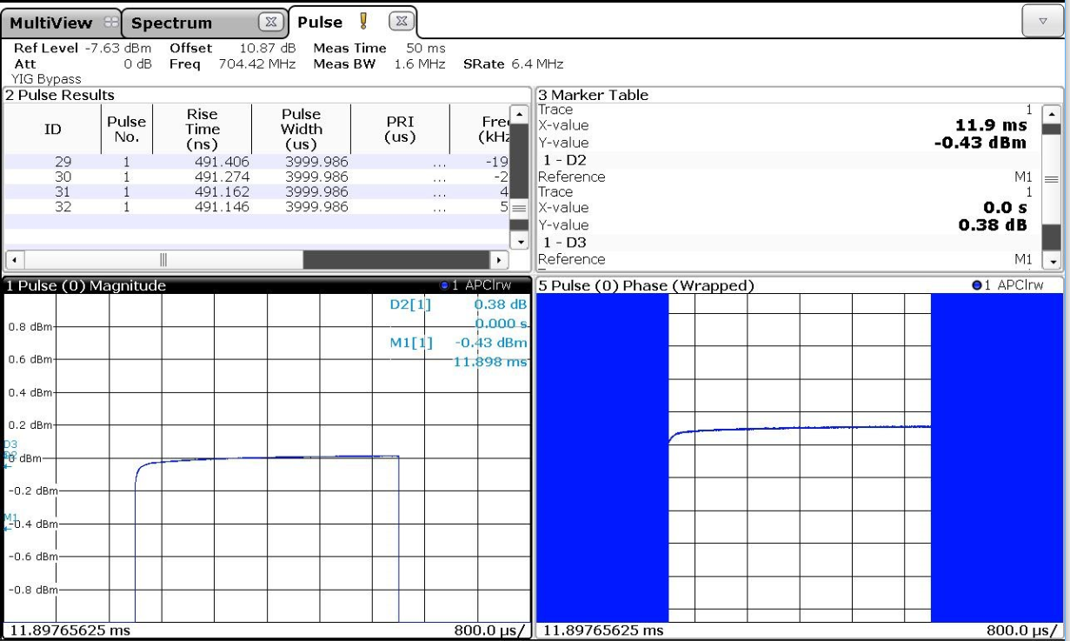

Result

RF pulse droop: 0.05 dB

Phase stability: 0.5°

Signal generator and PMU905, Pout 53 dBm at 704.420 MHz

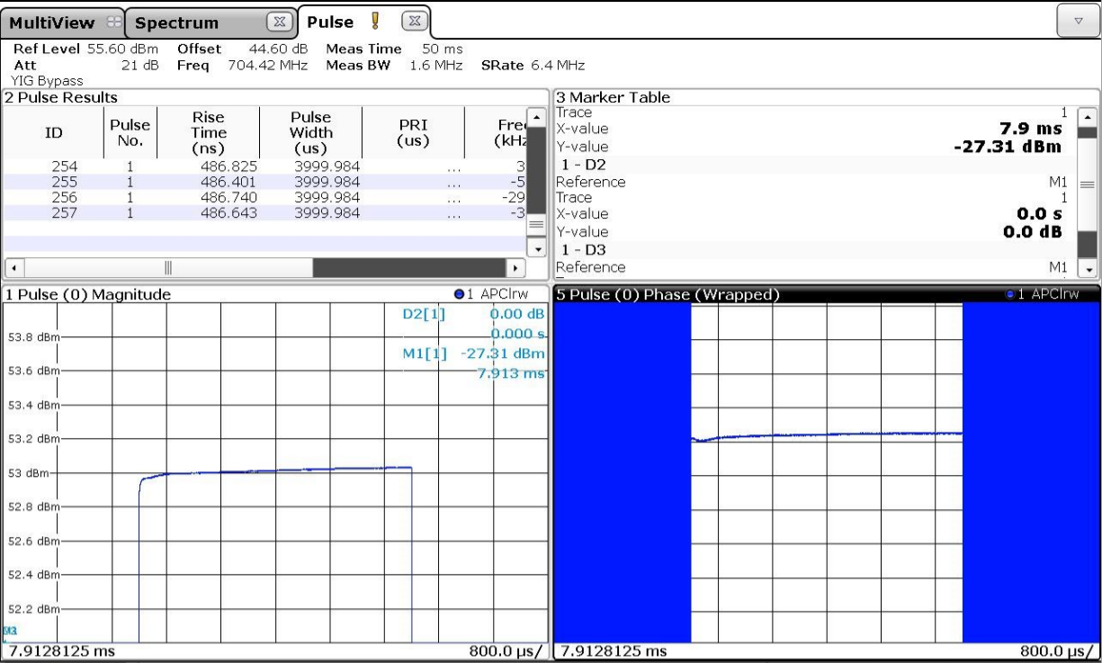

Result

RF pulse droop: 0.05 dB

Phase stability: 0.5°

### Phase and gain between RF pulses at Pout 200 W

Measurement device

Spectrum analyzer R&S FSW50

Signal generator R&S SMA100A in pulse operation

Pulse characteristic: Duration 4 ms, repetition rate 70 ms,

The FSW50 has got the 10 MHz reference of the SMA

**A number of 32 pulses has been recorded.**

Signal generator and PMU905 Pout 53 dBm at 704.420 MHz

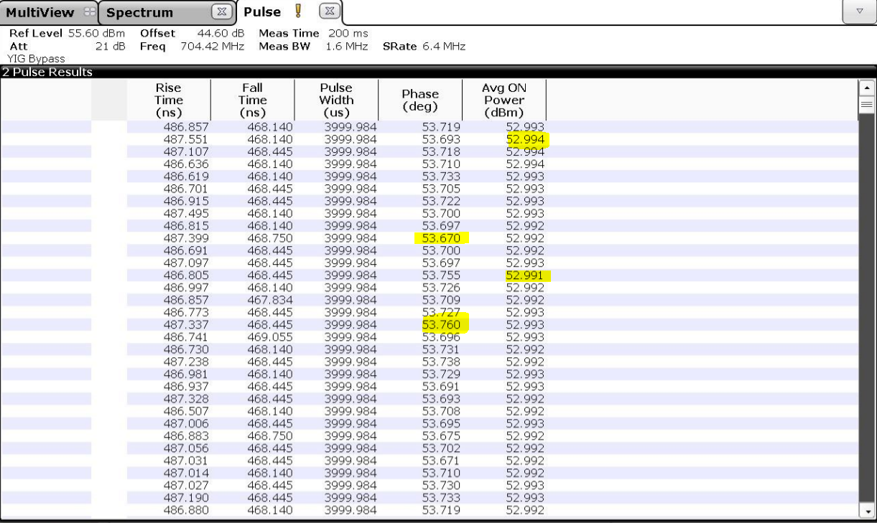

Result

Max pulse to pulse power stability: 0.003 dB

Max pulse to pulse phase stability: 0.09°